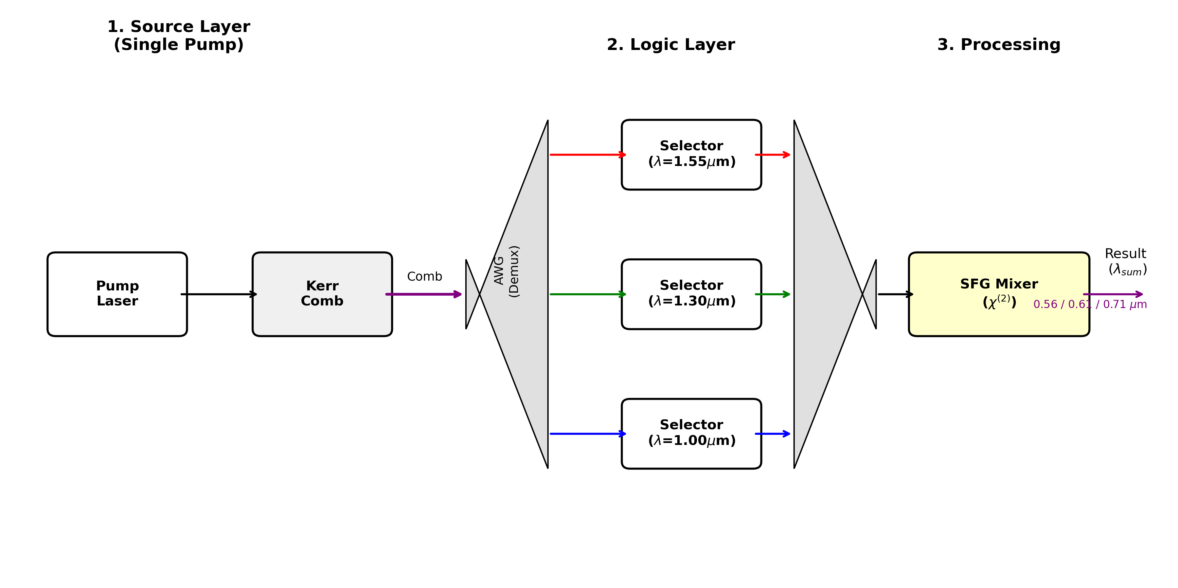
Three distinct frequencies of light are generated. The selectors will inhibit one wave of light allowing two to pass. The two selected waves of light will meet at a junction and travel to the Sum-Frequency Generator (SFG) for mixing. The SFG will generate a new unique frequency of light that is easily detectable as the result.

Christopher Riner Independent Researcher: Chesapeake VA
Chrisriner45@gmail.com

